**KUBERNETES**

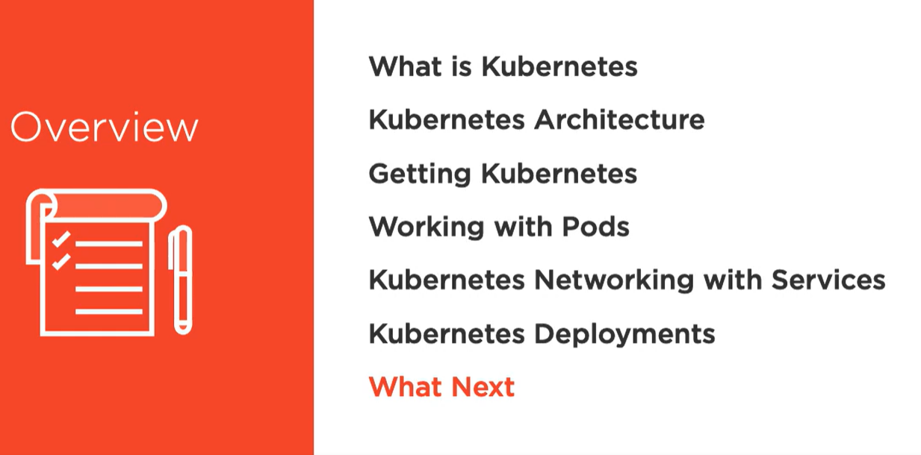

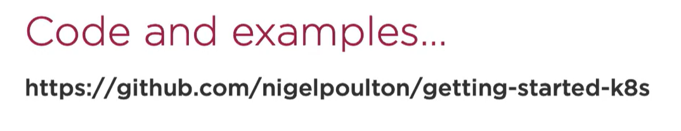

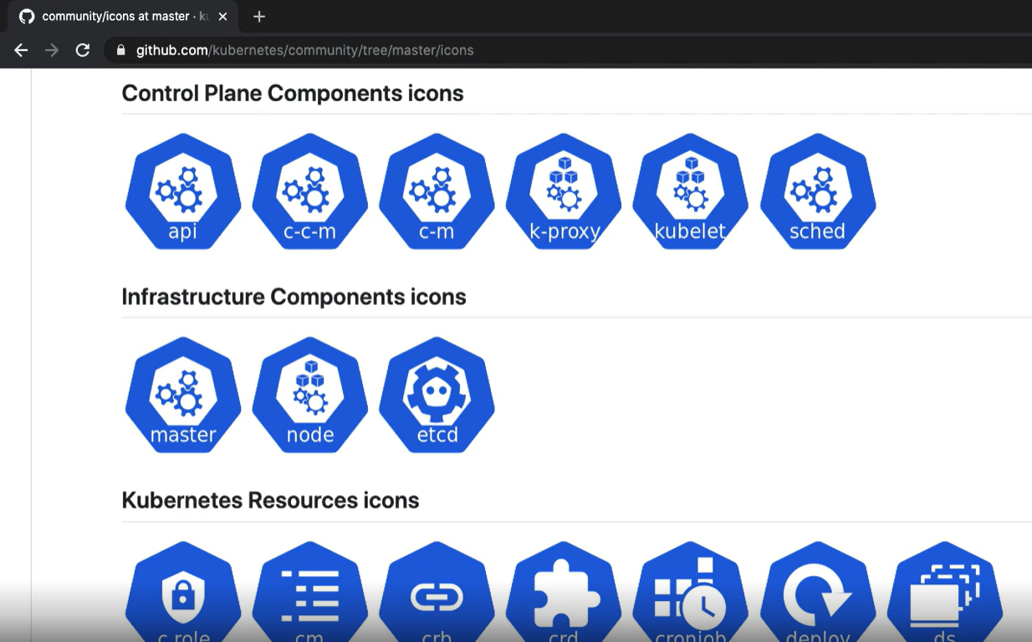

**HISTORY**

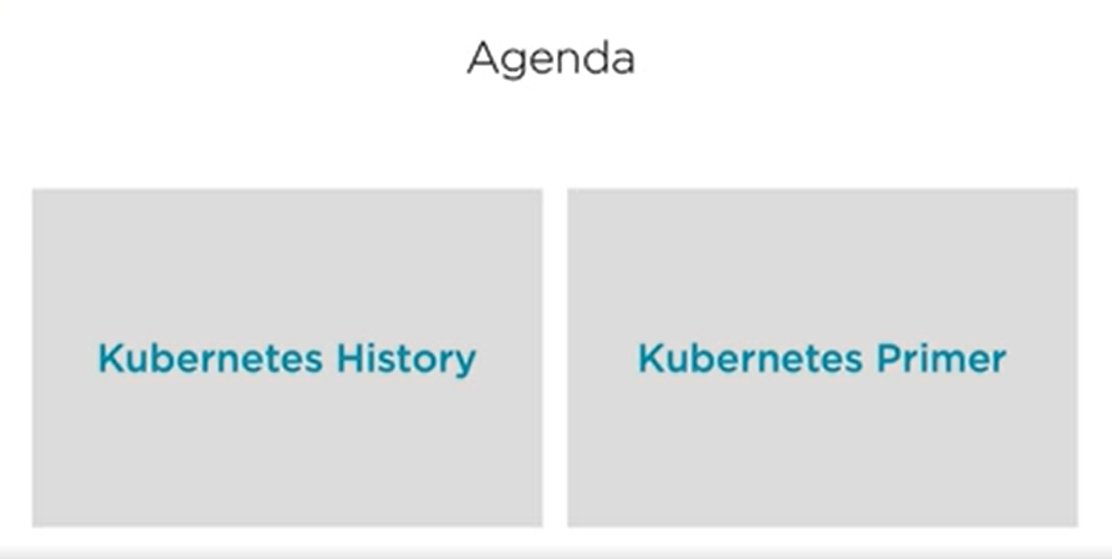

* Kubernetes is originated by google.
* But in 2014 it was handed over to open source cloud native computing foundation.

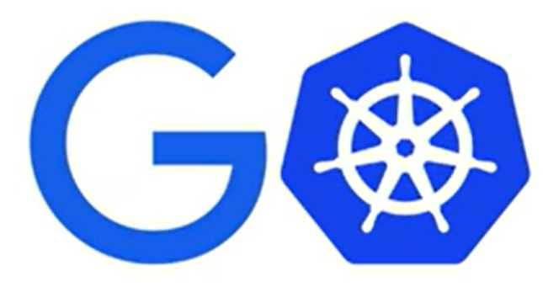

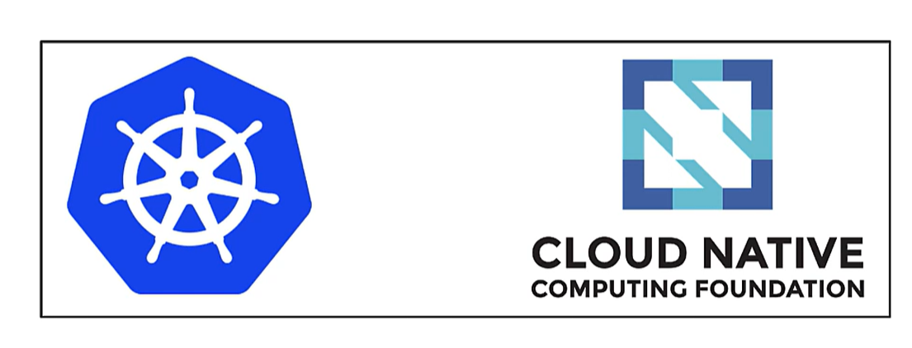

* Like most cloud project it is written in GO language

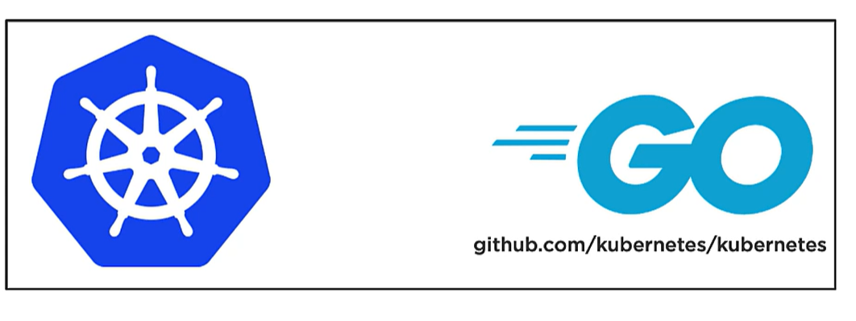

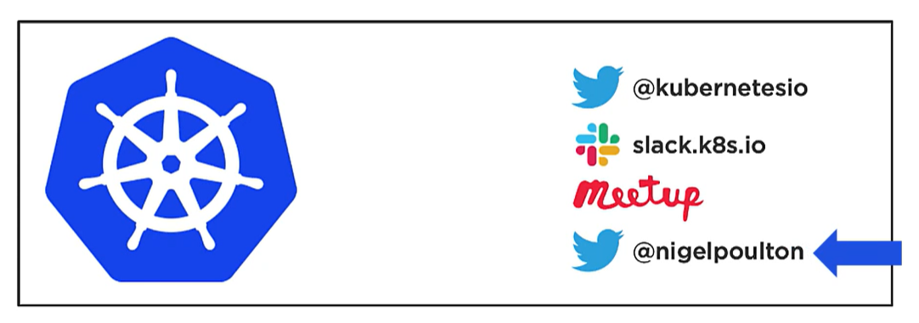

* It is related with google **Borg** and **Omega** (which is google in house container management tools)
* Kubernetes is born and developed by same developers but is open source now.

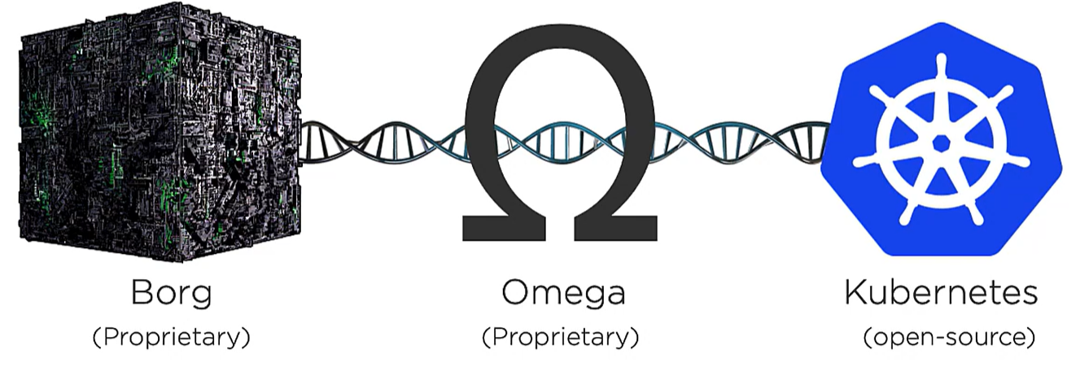

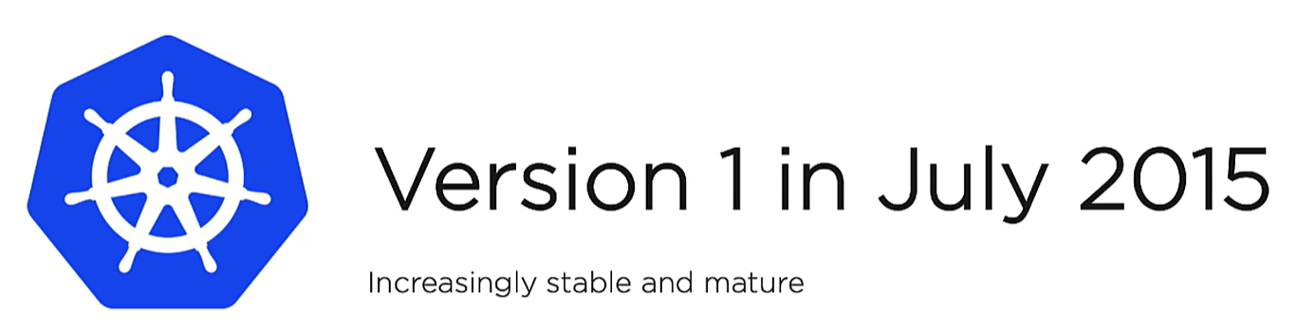

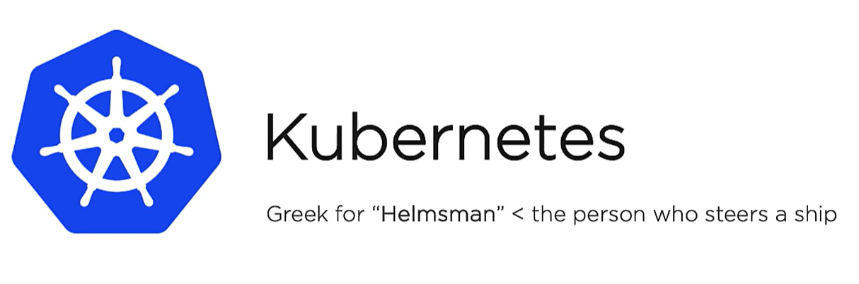

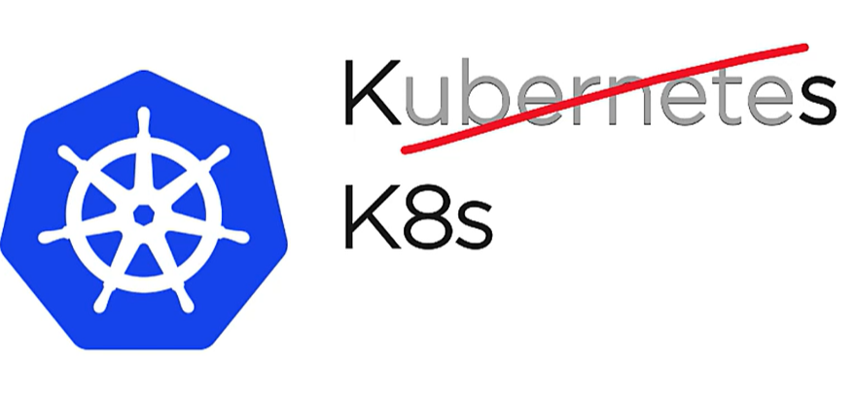

**WHY Kubernetes?**

In the container and microservices world we have tons of services and containers running them. To manage all of this

* How replicas will be load balanced on nodes
* How networks are created
* How to route request etc etc

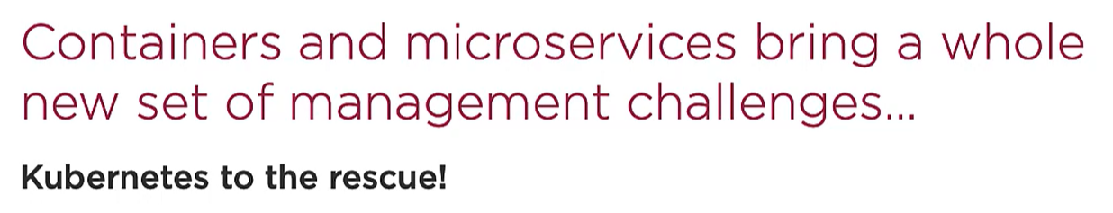

Just like we have an operating system which manages all hardware (CPU, RAM, processing etc) and end user with the help of OS communicates with it.

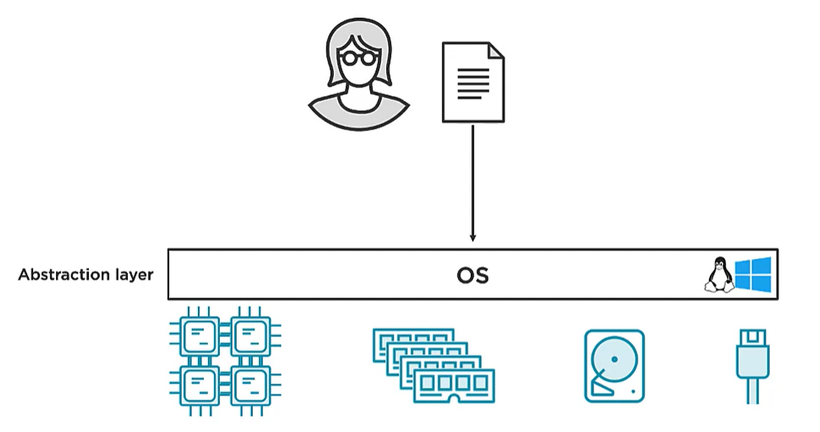

Similarly, Kubernetes helps us do abstraction with the cloud VMs and nodes. We don’t need to bother which node our application is running on

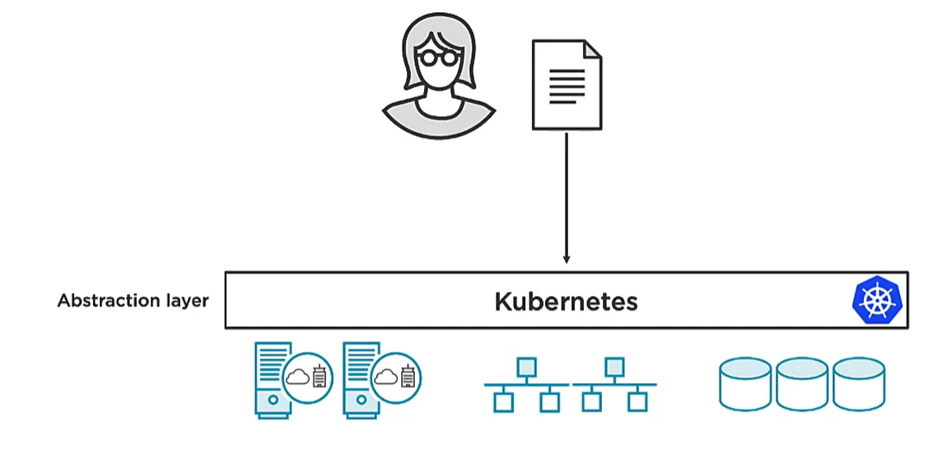

We go to K8s and say here is my app and bunch of services run it for me and K8s does all the stuff ( run on nodes, load images, attach networks etc)

We package our apps as containers, creates a manifest stack file and give it to K8s and it will do all job.

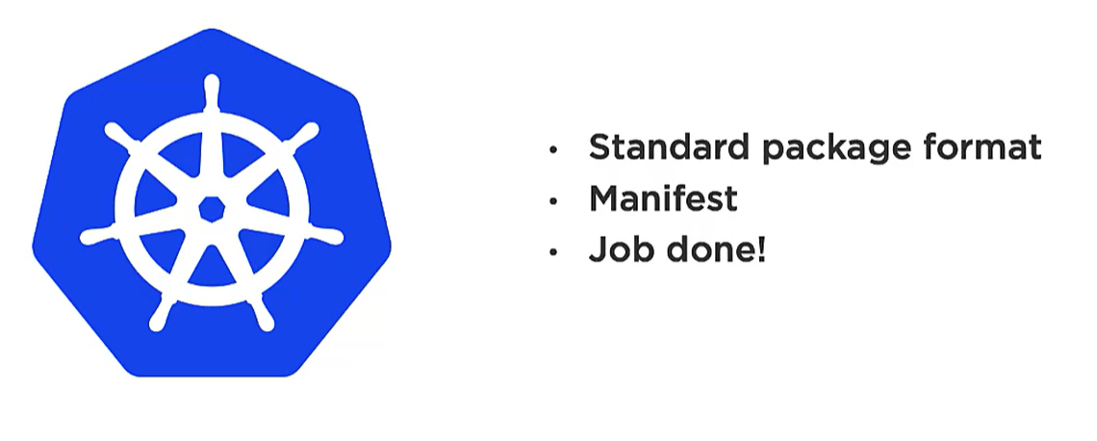

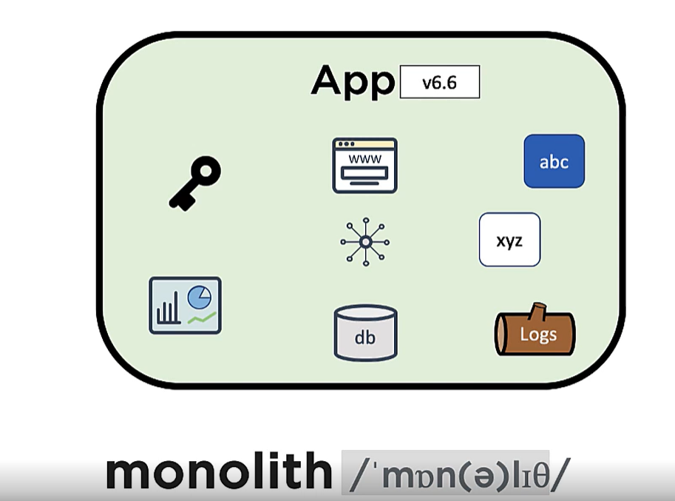

We have multiple services bundled together in a single giant program. They are tightly coupled, build and deployed together.

They are replaced with **cloud native microservices apps.**

**Microservices** breaks the monoliths services and make individual apps which is loosely coupled, **build , packaged , scaled and shipped** independently.

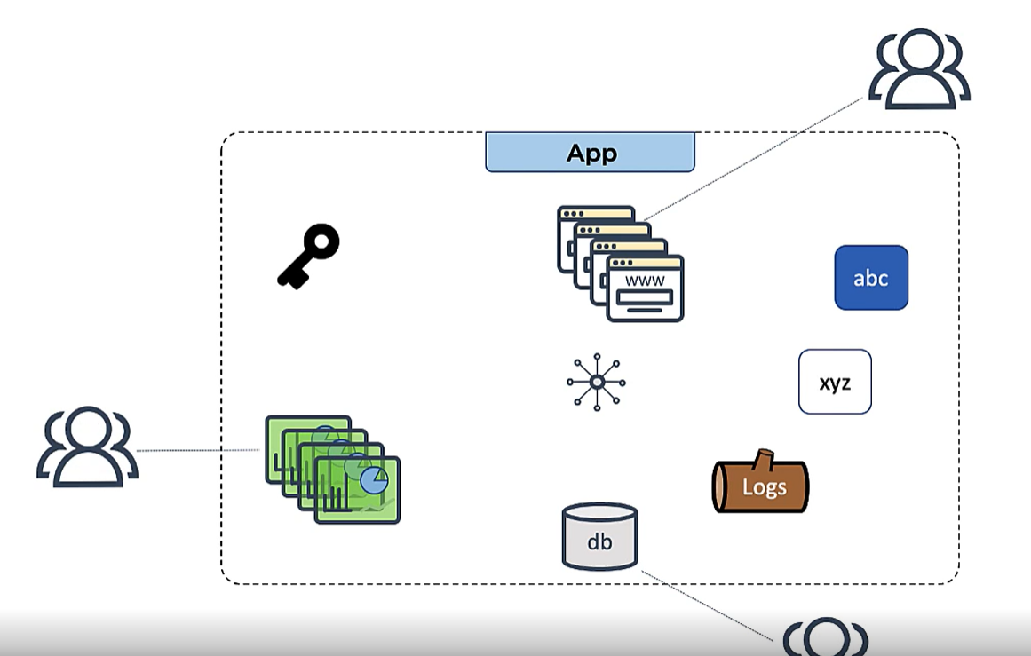

We do have challenges with microservices. Each service has to talk to each other and development teams needs to be in sync.

**WHAT DOES CLOUD NATIVE MEANS?**

**It means these services can run anywhere which has Kubernetes. Each service communicates with each other through APIs.**

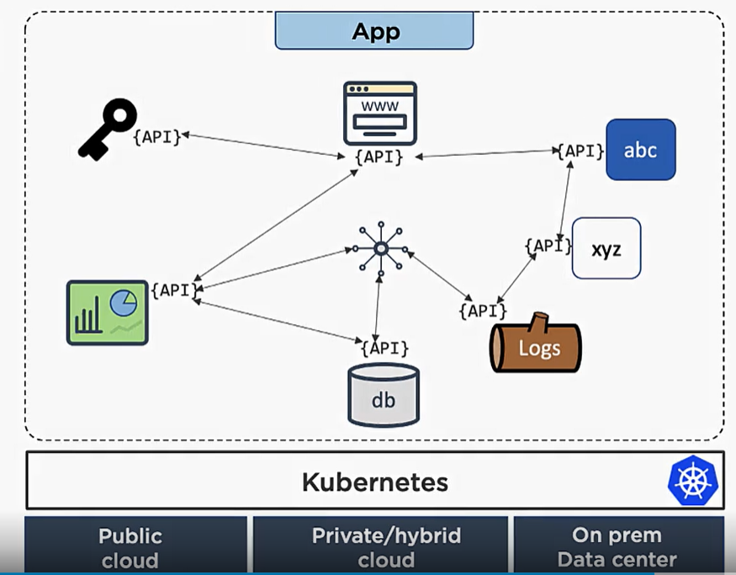

**ARCHITECTURE**

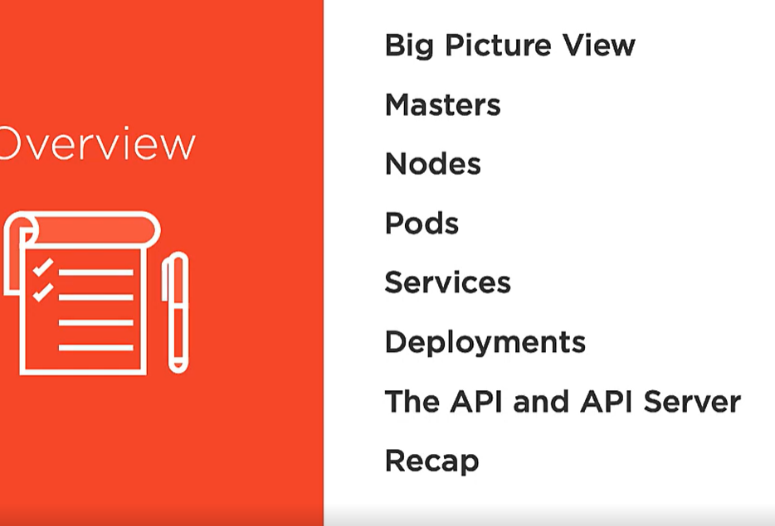

Kubernetes is an **orchestration tool** for microservices apps (services that are independent).

* **What we mean by orchestration?**

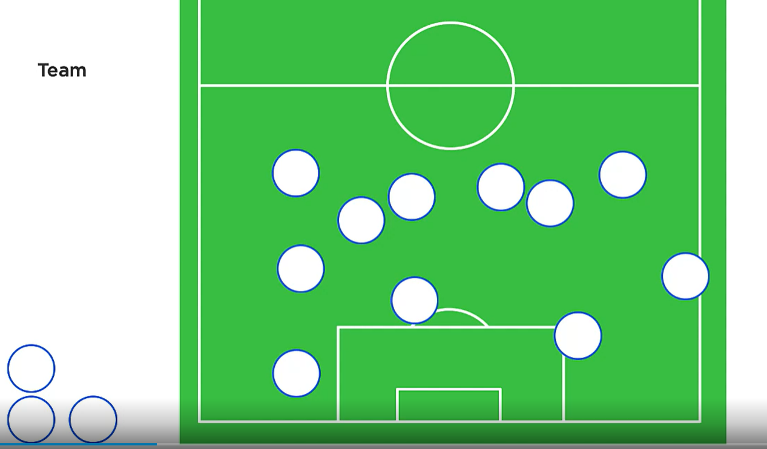

* Each players are independent has their own ability and skills.
* Now comes a coach/manager who assigns roles to each player and gives them responsibility and organize them.

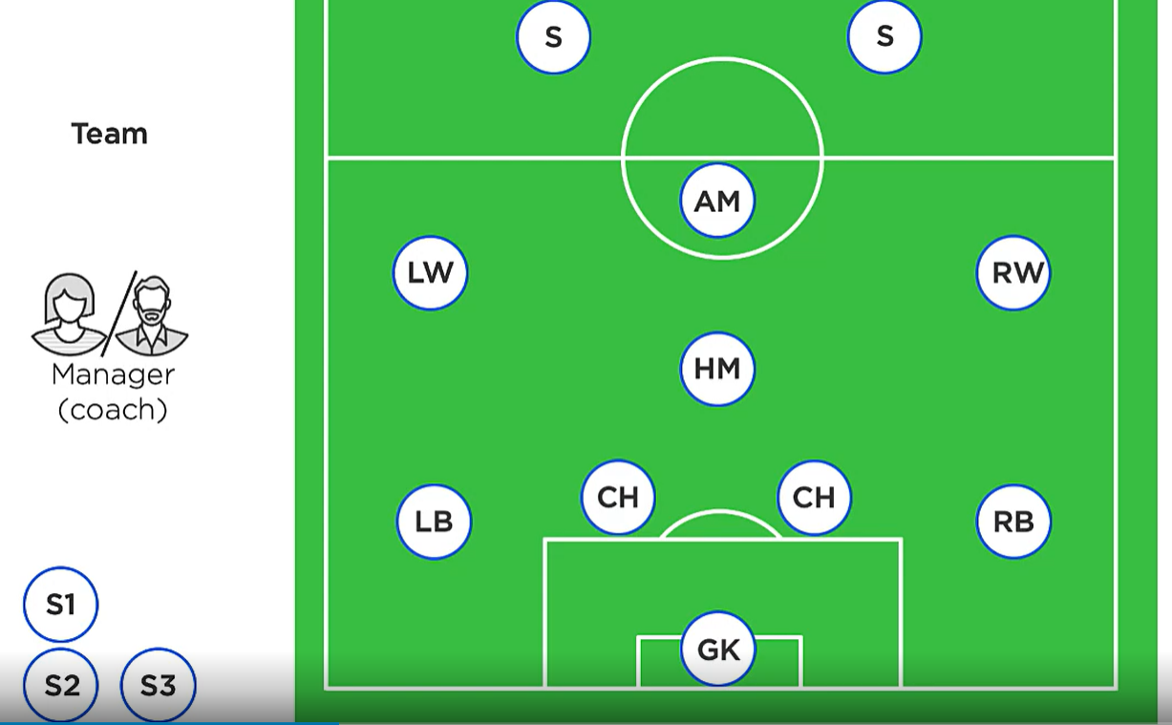

* Coach makes sure all payers follow a plan as well as he keeps on monitoring the status of each player and replace injured one with new players.
* **Constantly monitoring the dynamic situation.**

**In Microservice and Kubernetes world**

* We have an app with multiple individual services, each package as a container.

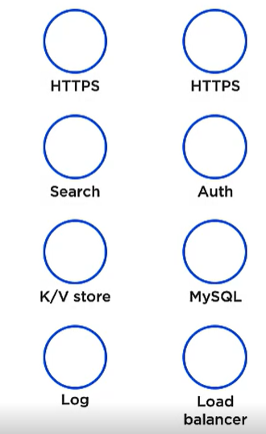

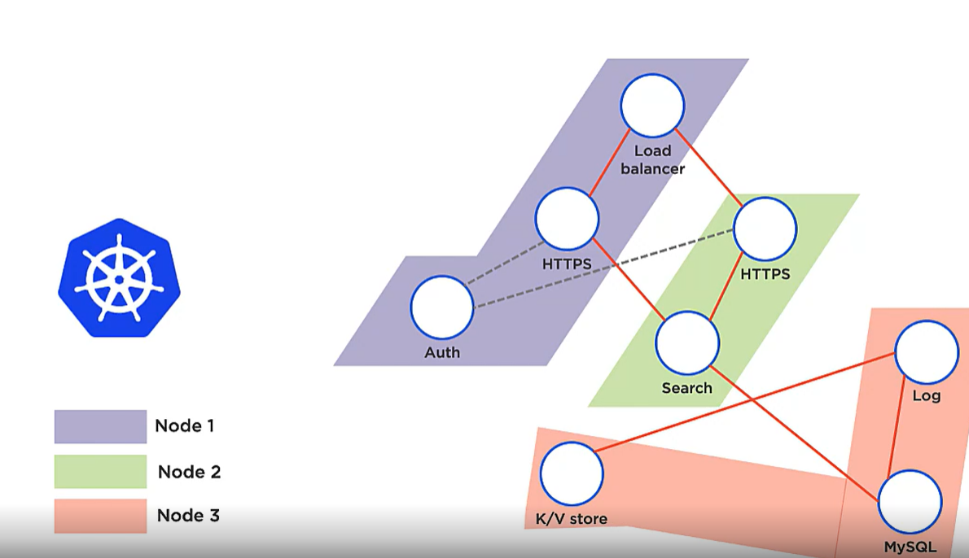

Now K8s comes along and organizes each service into a useful app.

* So we have an microservice app , we create a manifest file **YAML file** ( which contains all declarative details of how many services we have, images used , networks , volumes and how many replicas we need etc etc).
* We package the app give it to the K8s cluster.
* Cluster is having master and worker nodes.
* Master is like brain of cluster**. Cluster control plane. Manages , monitors and schedule jobs etc.**
* **Nodes are one which run our apps.**

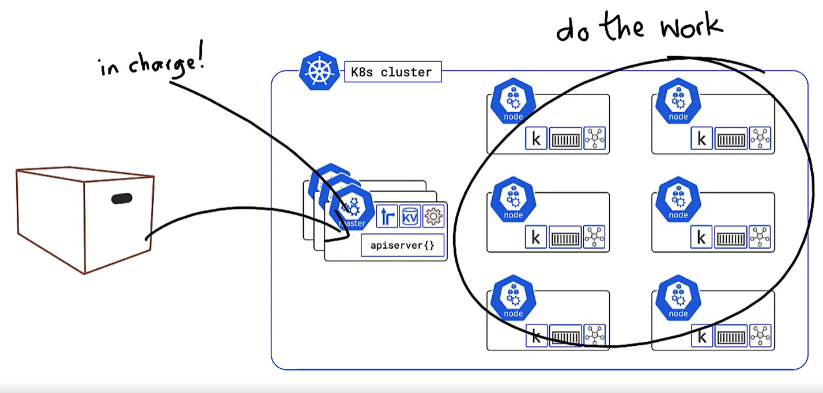

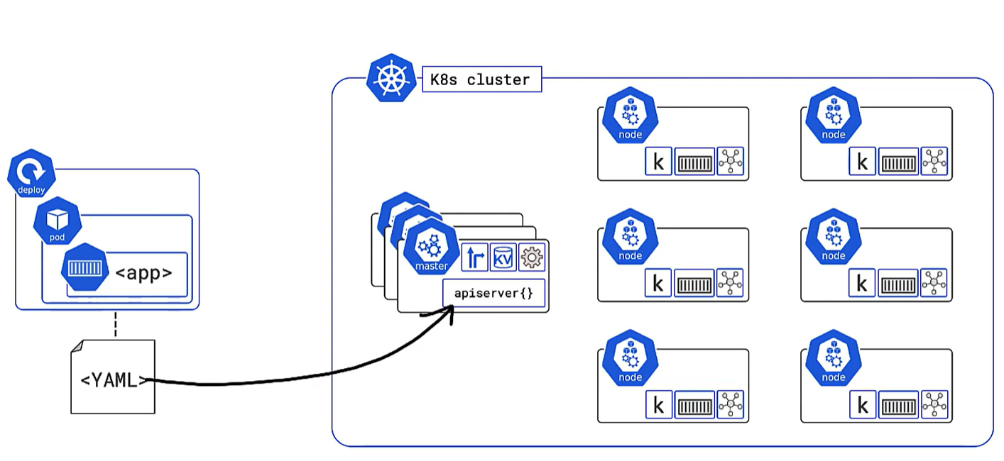

**MASTERS**

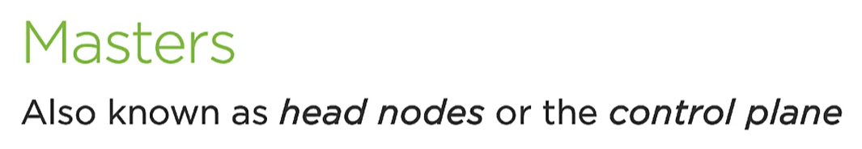

* Masters are the brain of cluster so they should be always available. We should always create a multi-master either 3 or 5 or 7.
* We should always deploy masters in different domain connected by a faster network. For **high availability.**

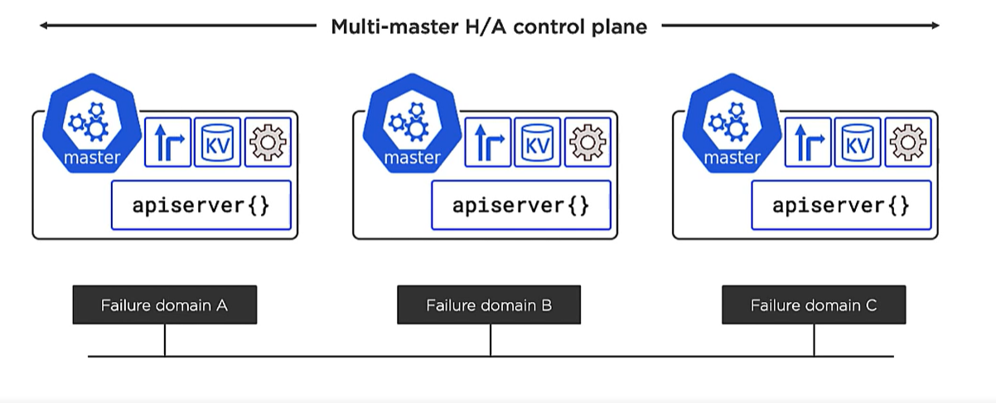

Master more than 5 means cluster will need more time to meet the consensus.

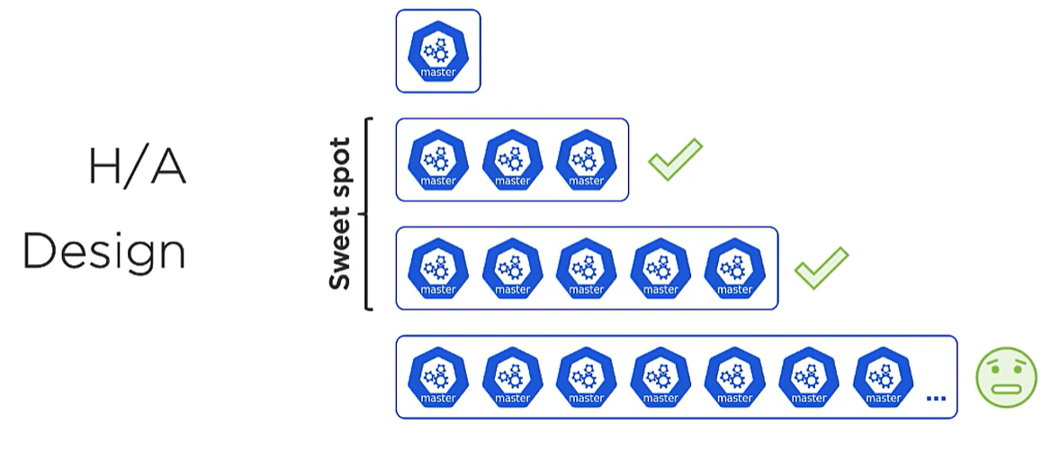

**Why odd number** is to reach to a consensus faster. Mitigate split-brain issue with even number.

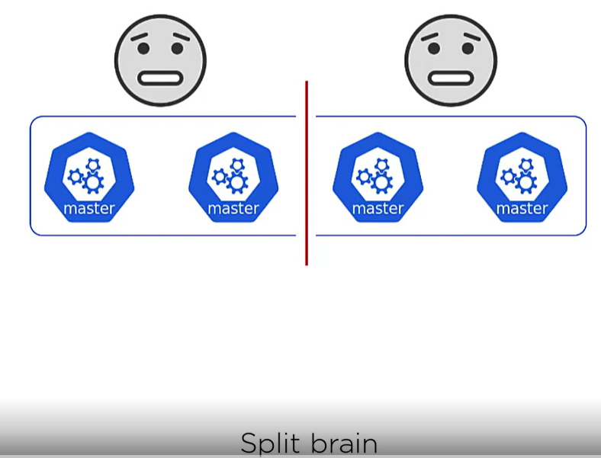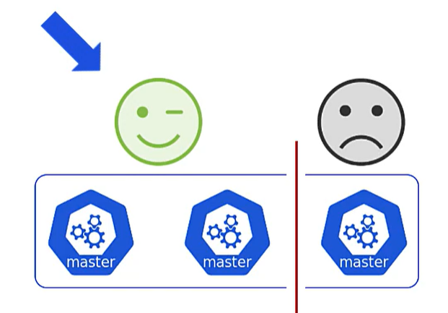

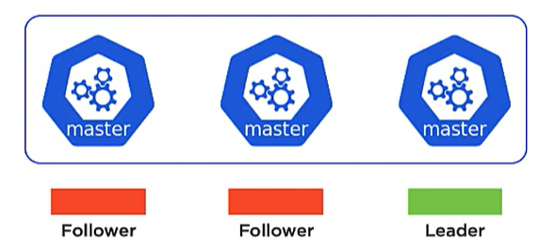

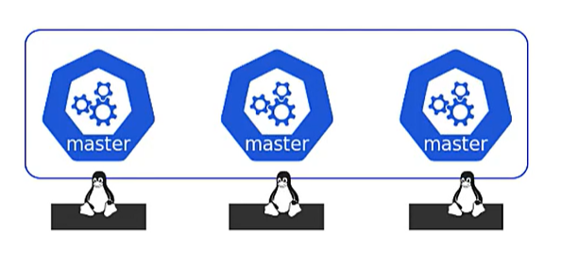

When we are creating our own K8s clusters we need more than one **linux machine** as these masters are individual nodes(machines).

**HOSTED K8s platform**

* If we are using hosted K8s platform as a service like Amazons elastic K8s service (**EKS**) or google K8s engine (**GKE**), Azure Kubernetes service (**AKS**).
* So the cloud provider will run K8s as a service.
* Masters are hidden.
* All control plane jobs are outsourced to cloud providers.
* We get a production grade cluster with 0 effort.

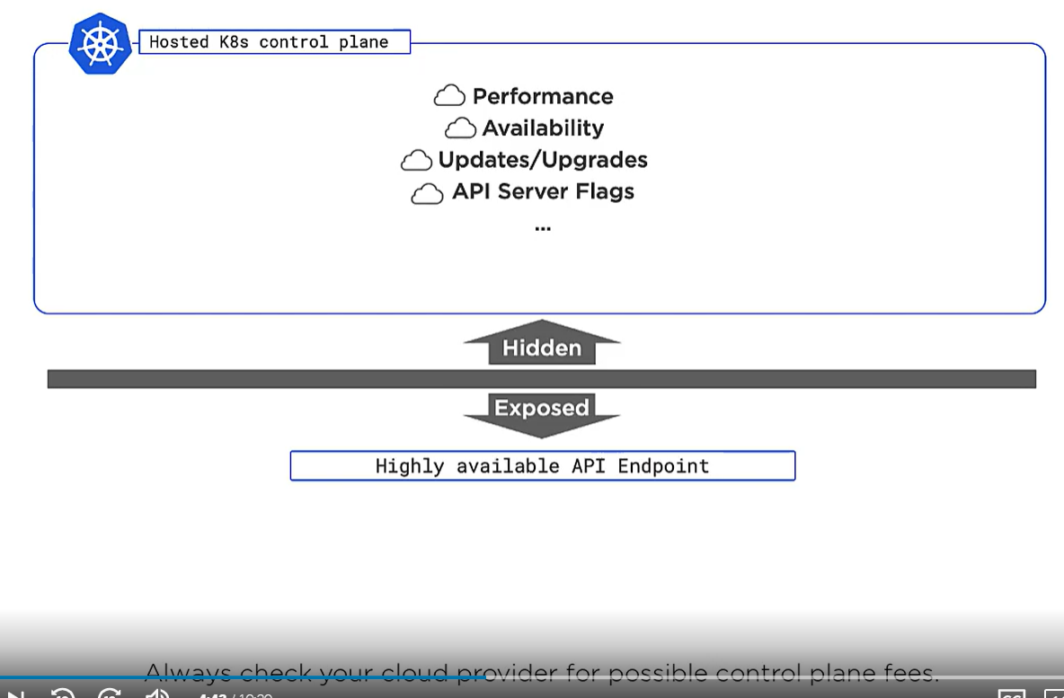

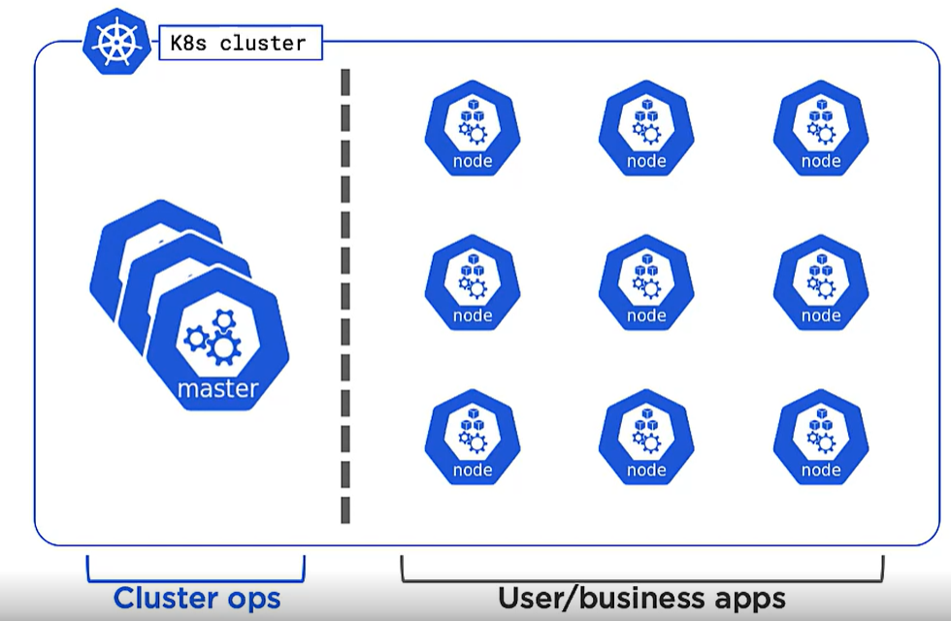

**MASTER COMPONENTS**

1. **ApiServer{}** is a gateway to the cluster.

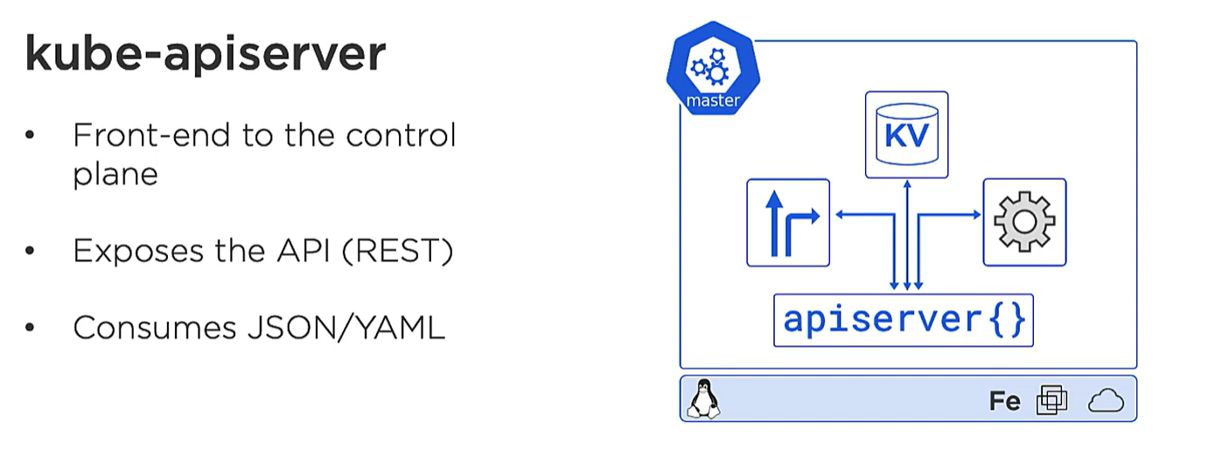

* It is the only master component which talks to nodes, users. If the apps hosted on nodes needs to talk to control plane it uses the apiserver.
* Even the control plane services talk to each other via apiserver.
* We sends our yaml file or manifest file describing our apps to apiserver{}. Apiserver authenticate it and directs other control plane feature to deploy the services on to various nodes.

1. **CLUSTER STORE**

* The only persistent component of entire control panel.
* It stores the config and state of cluster as well any apps running on it get stored.
* Based on **etcd nosql database**.

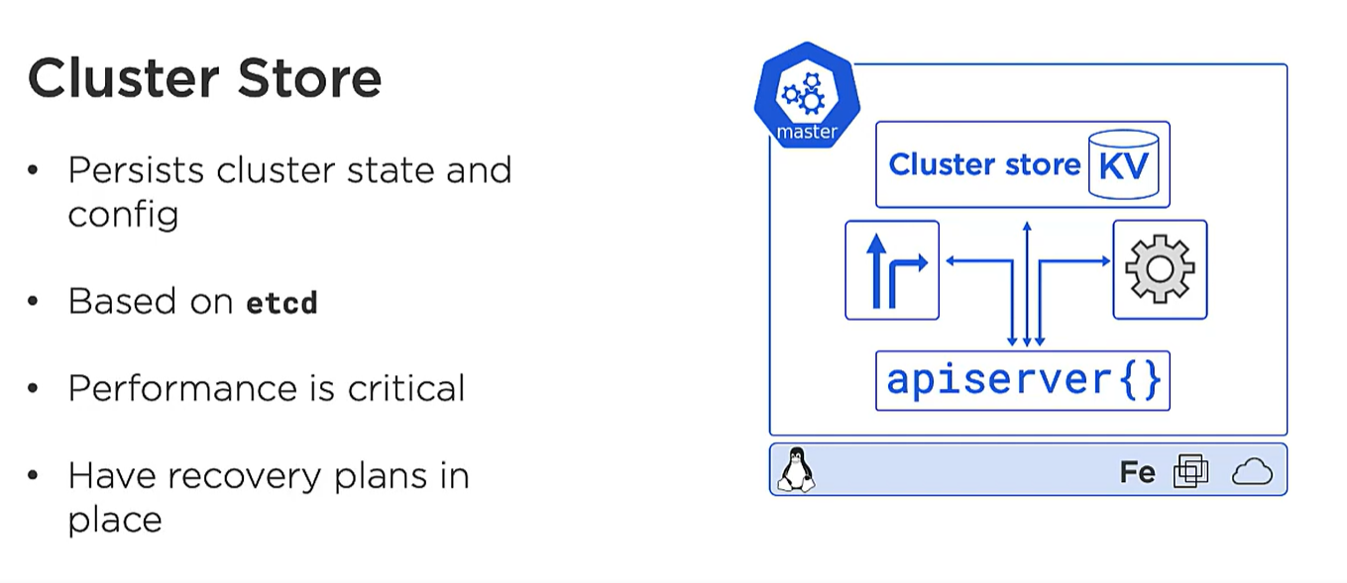

1. **Kube-controller-manager**

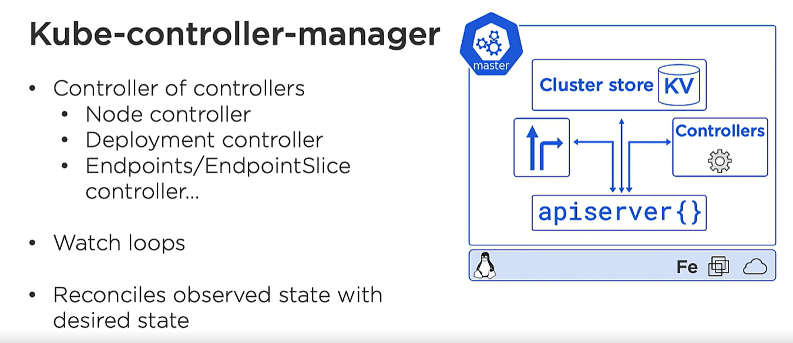

1. **Kube-scheduler**

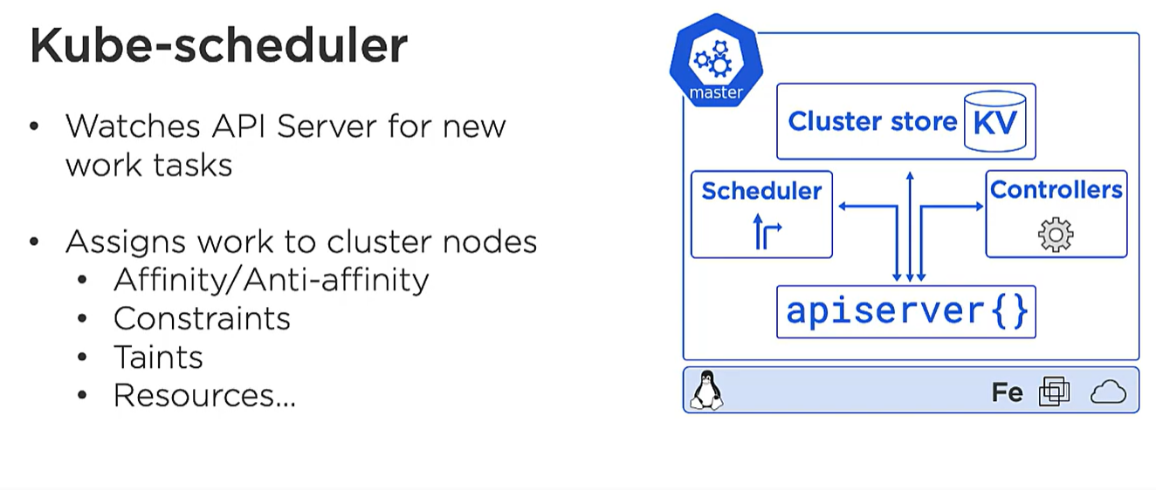

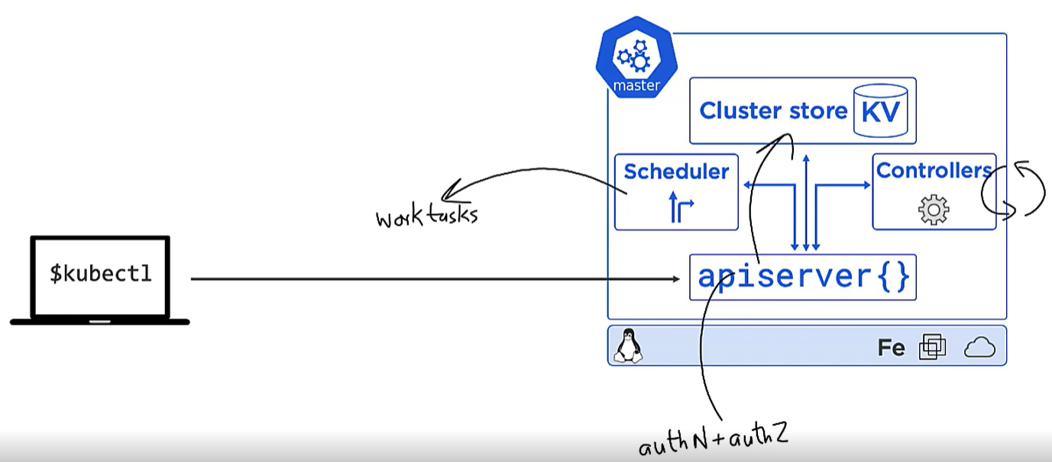

* Users commands or queries(basically yaml file) comes to apiserver{}
* Apiserver authenticate and authorize it.
* Now if our command is to deploy new app then desired state is written on a cluster store.
* Schedulers then form a work tasks to the node in a cluster.
* Controllers keeps on monitoring the nodes ,making sure the actual state matches the desired state.

**WORKER NODES**

**It has 3 components:**

1. **Kubeletes**
2. **Container runtime**
3. **Kube proxy**

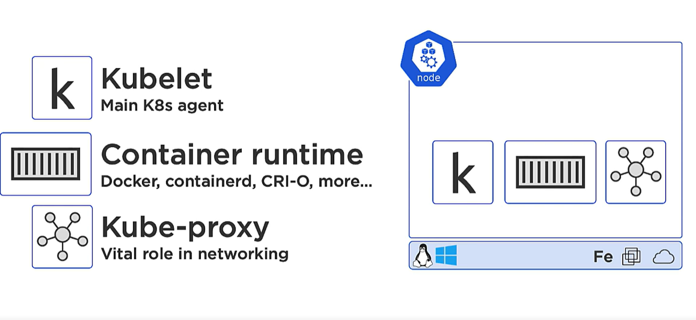

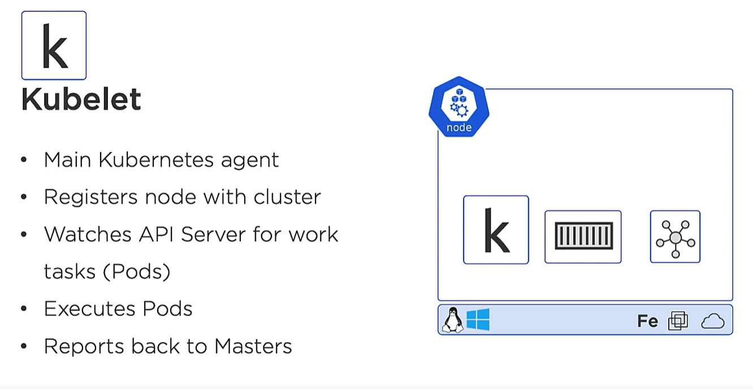

* Our nodes can be a window or Linux machine. It can be VMs or cloud instances. We just install a kubeletes.
* Once we have kubeletes it registers our machine as a node in a cluster.
* It adds the machines CPU, RAM etc. to overall cluster resources.
* Once node is added to the cluster, the scheduler in master can now assign work to the node.
* Work in a K8s cluster comes as a Pod. **Pod is one or more container package together as a single deployable unit.**
* It is the work of a kubeletes to constantly look for master for any new pods assign to it.
* But kubeletes does not know how to run the containers or load images from Pod.

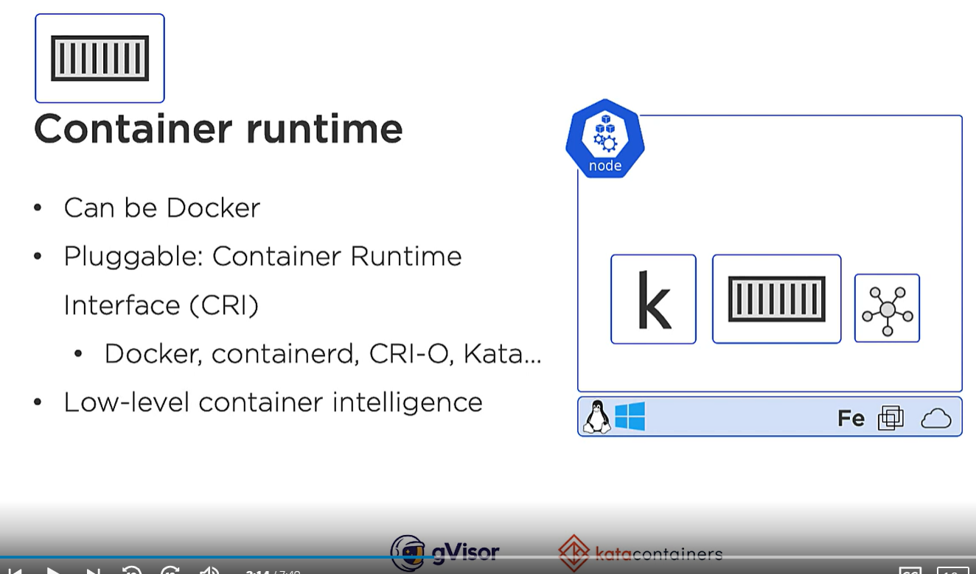

We have docker for container runtime but K8s has pluggable CRI to interface with other container D providers.

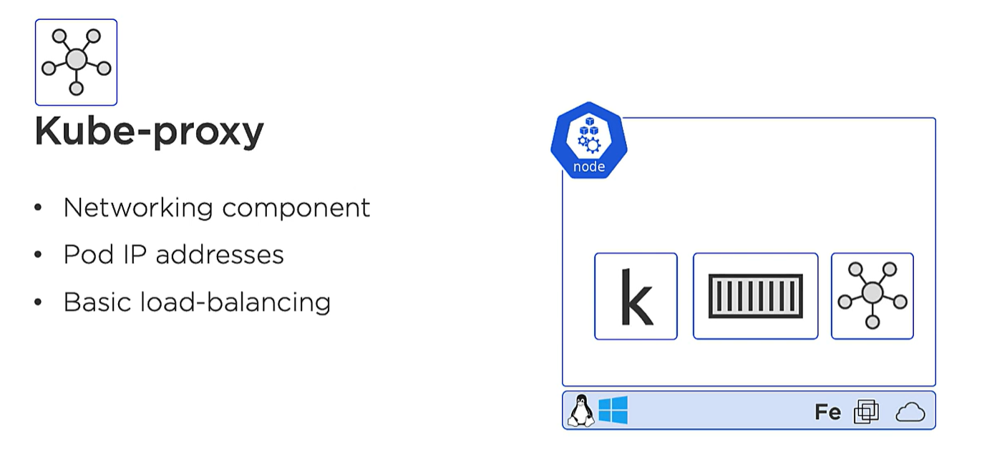

1 IP per Pod. If we are running multiple containers in a pod all containers will have same IP.

A lot of cloud providers have nodeless cluster.

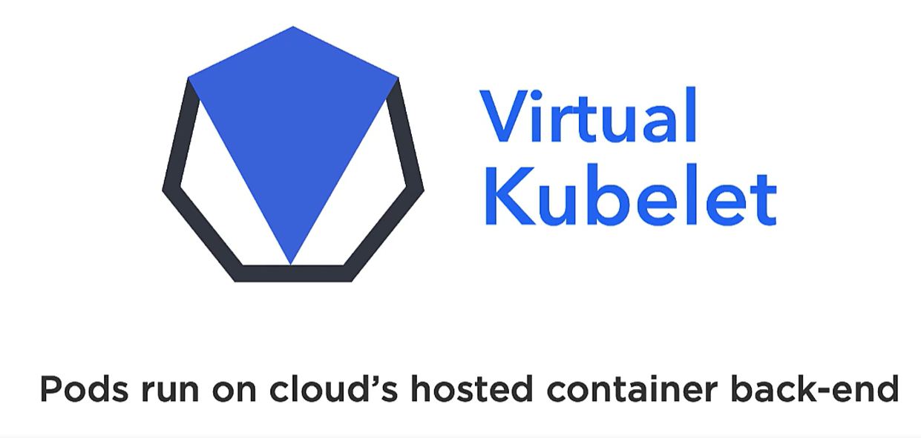

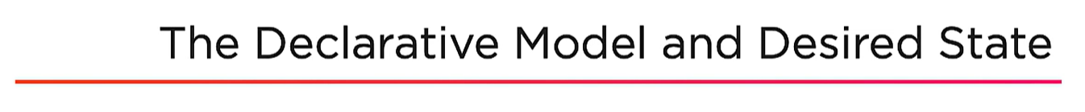



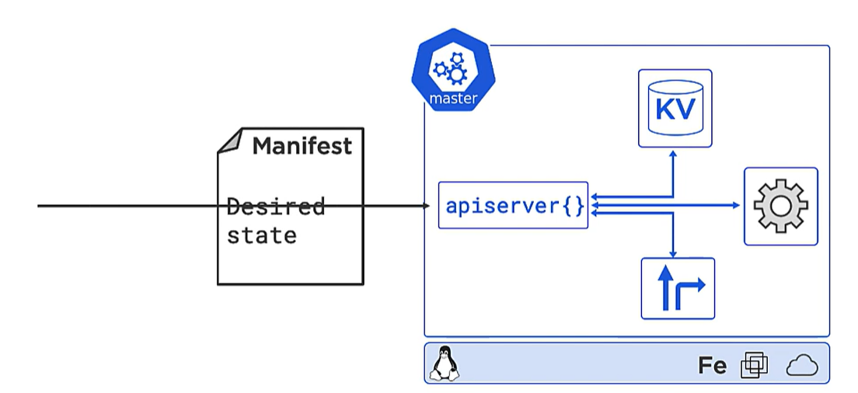

* We create our manifest file of what we want and give to the apiserver and
* The desired state is stored in cluster store.
* Now it is up to K8s cluster to decide what we want to do and it will always sync desired state with observed state.

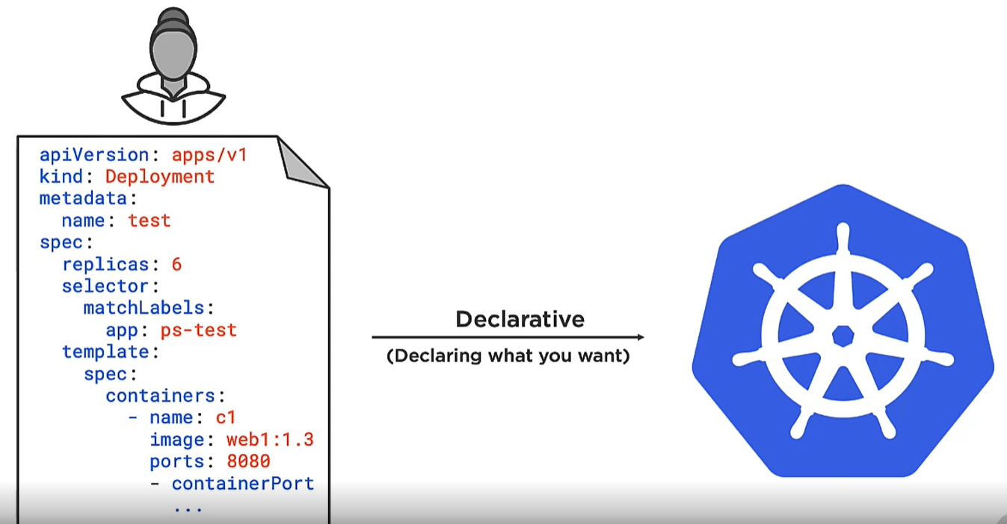

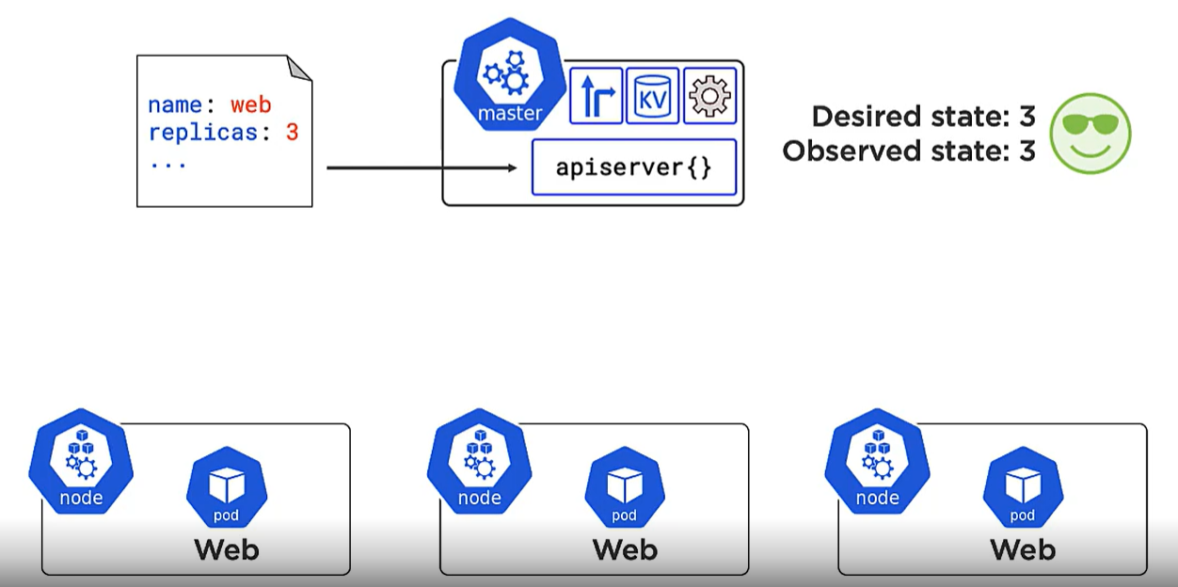

Here in our manifest we say we want 3 replicas of front-end web server.

So K8s will fire 3 pods on 3 nodes and desired and observed state is matched.

The **controller** will keep on the state.

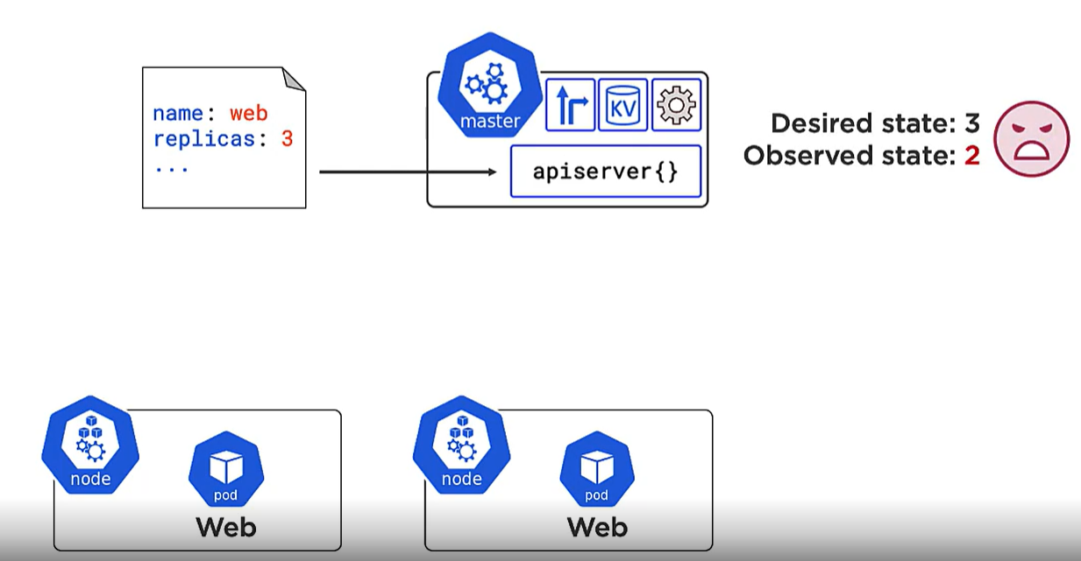

Now one of the nodes goes down and desired and observed state mismatched. So K8s will run one more replica on one of the nodes.

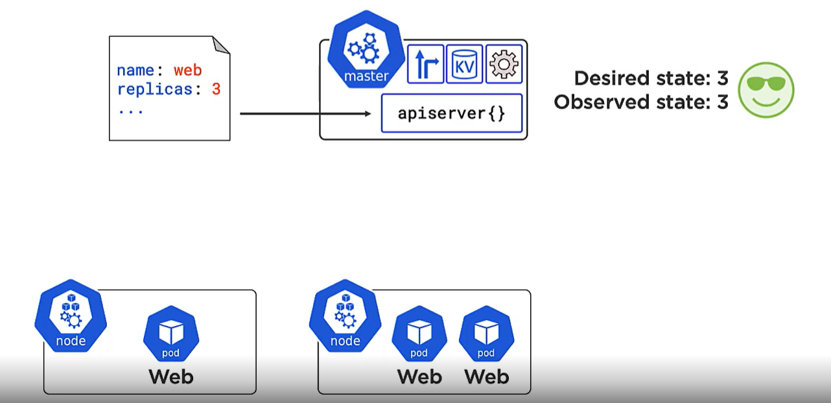

**OBSERVED STATE SHOULD SYNC WITH DESIRED STATE**

**POD**

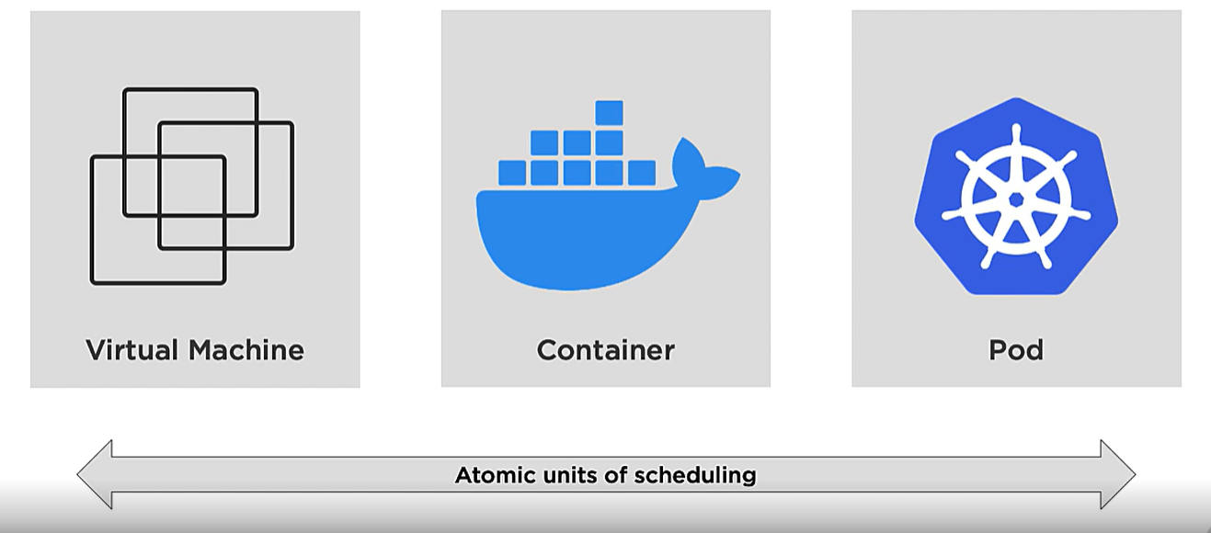

* In VM world atomic unit of deploying is Virtual Machine.
* In Docker it is container.
* In K8s its POD.

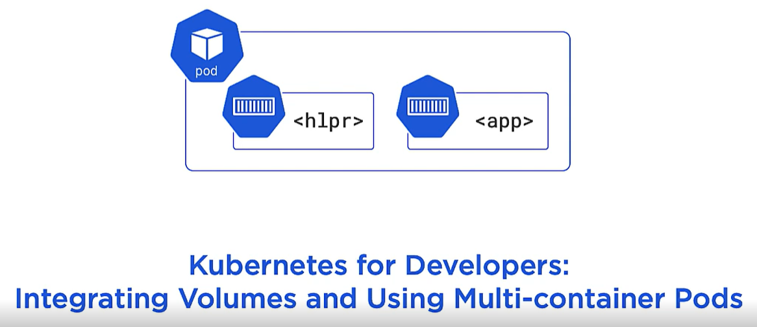

* We don’t deploy a container directly on K8s . Container always runs inside a POD.
* POD is a thin wrapper layer which contains the shared execution environment for container.
* 1 POD can have more than 1 container in it which shared the execution env( IP address, file system etc).

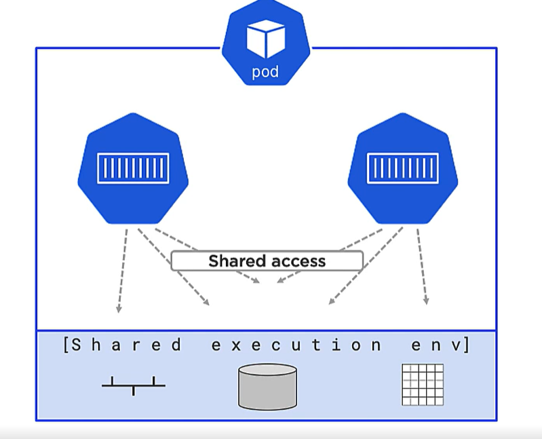

Container inside a POD shares same IP address so if we have to connect to a container from outside we need a port for each container.

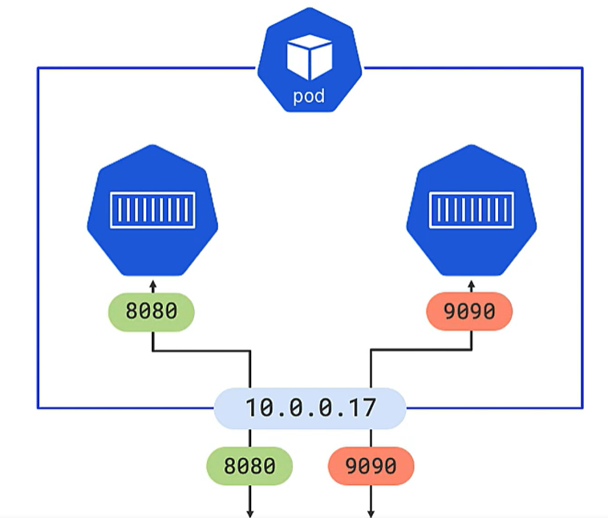

If container needs to talk to each other they use same port with localhost.

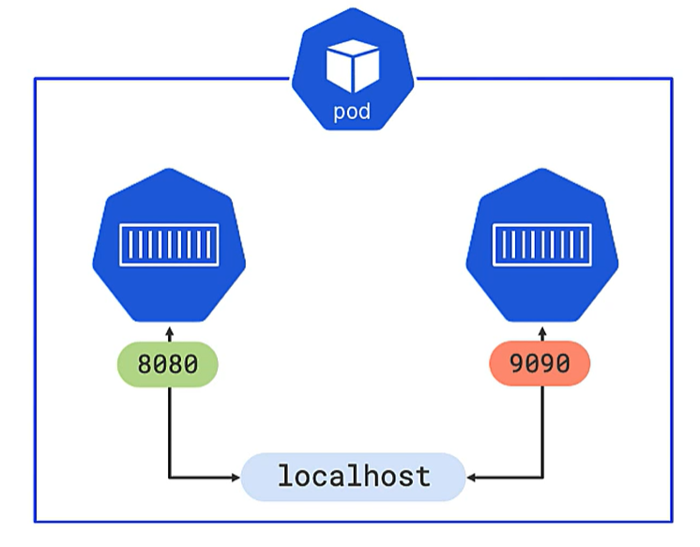

Normally we will run only 1 container inside a POD.

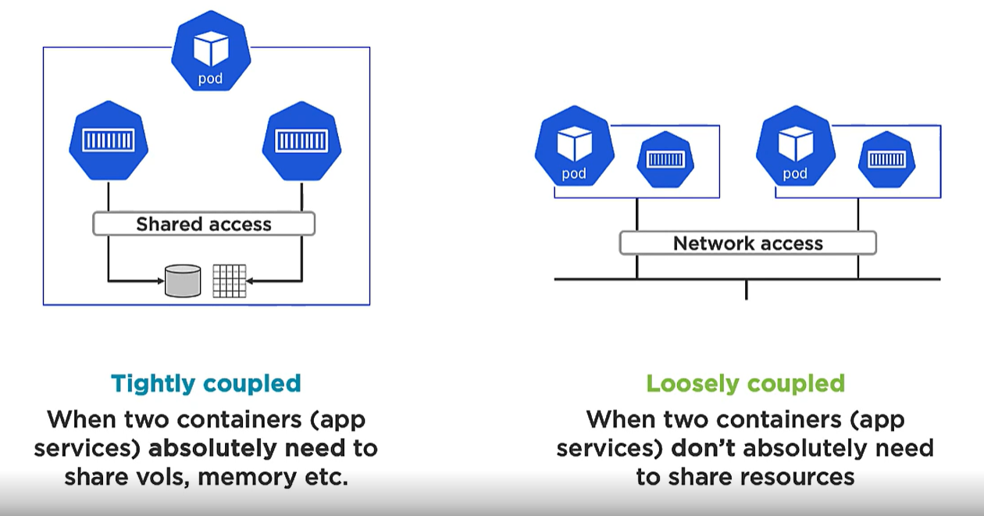

When it is absolutely necessary to have 2 containers inside a POD we do it.

**EXAMPLE: Service Mess**

In service Mess we inject an additional container when POD is deployed to the cluster.

Job of Mess container is to sit between main app container and the network. It does encryption and decryption of traffic coming in and out of POD

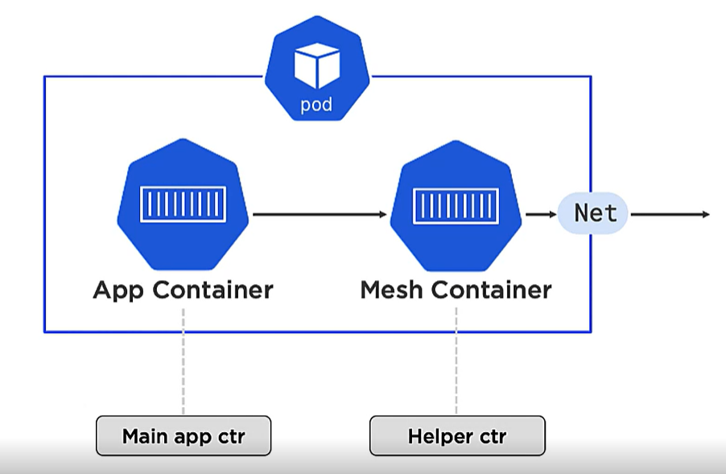

**SCALING IN K8s**

* The unit of scaling in K8s is POD.
* We create a new POD to scale more.
* **We don’t create multiple container inside a POD to scale**

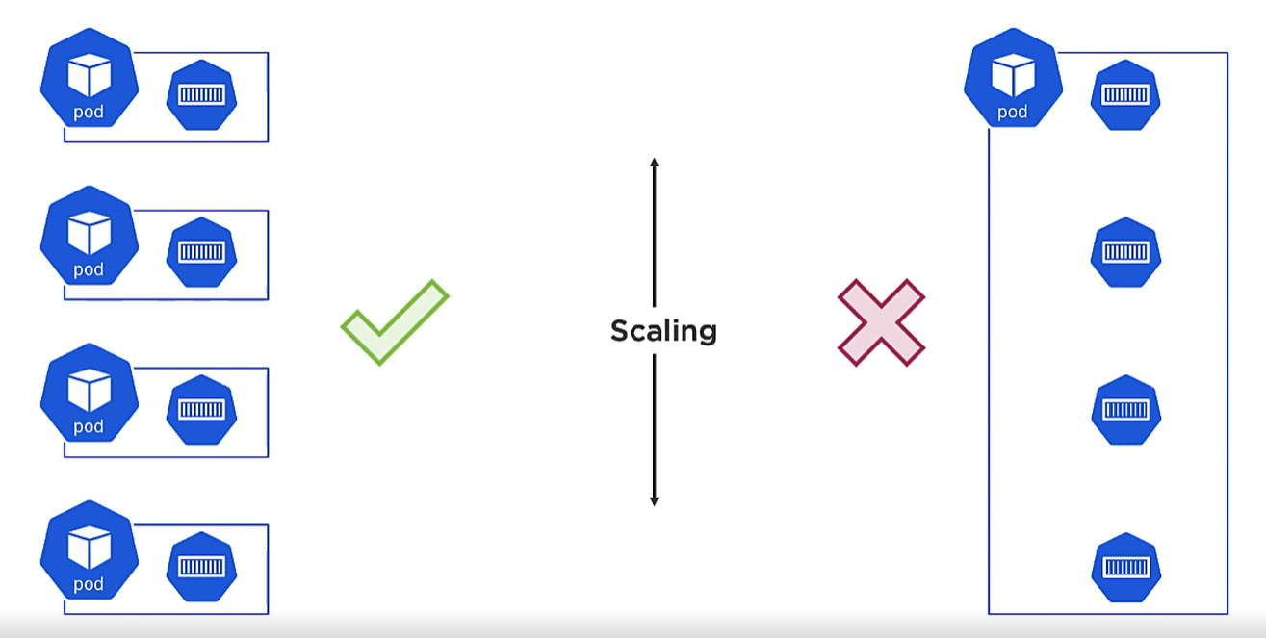

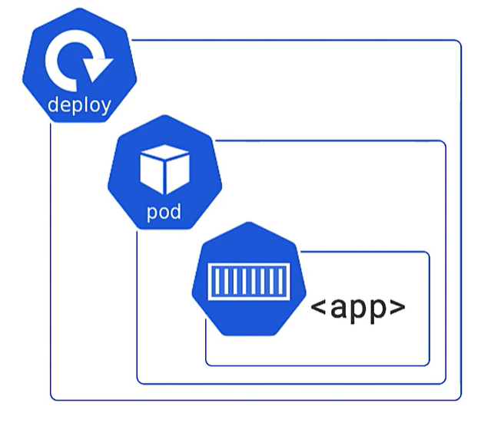

**PODs have an additional deploy layer which helps in scaling and self healing of PODs in a cluster.**

POD is not running until all containers inside POD is up and running.

All containers in a POD is scheduled to same node in cluster.

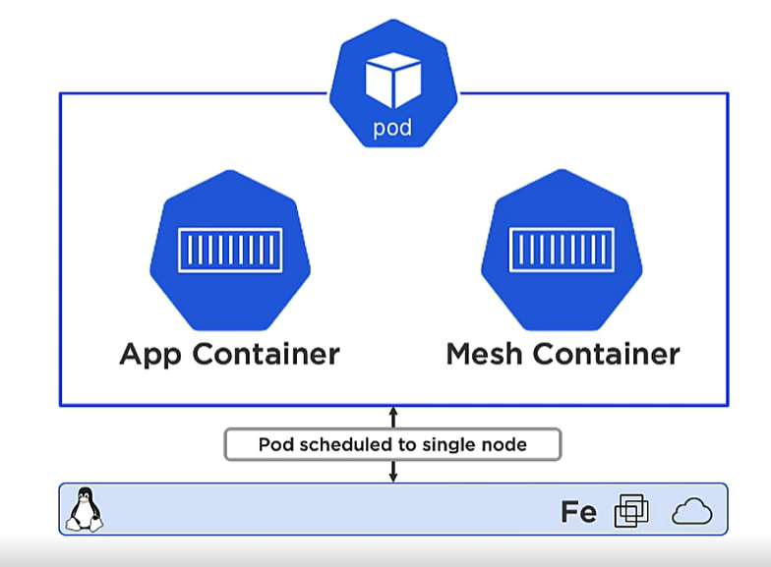

PODs are mortal.

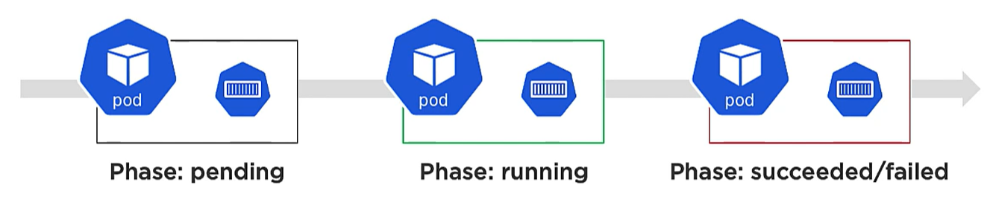

PODS benefits over normal container deployment:

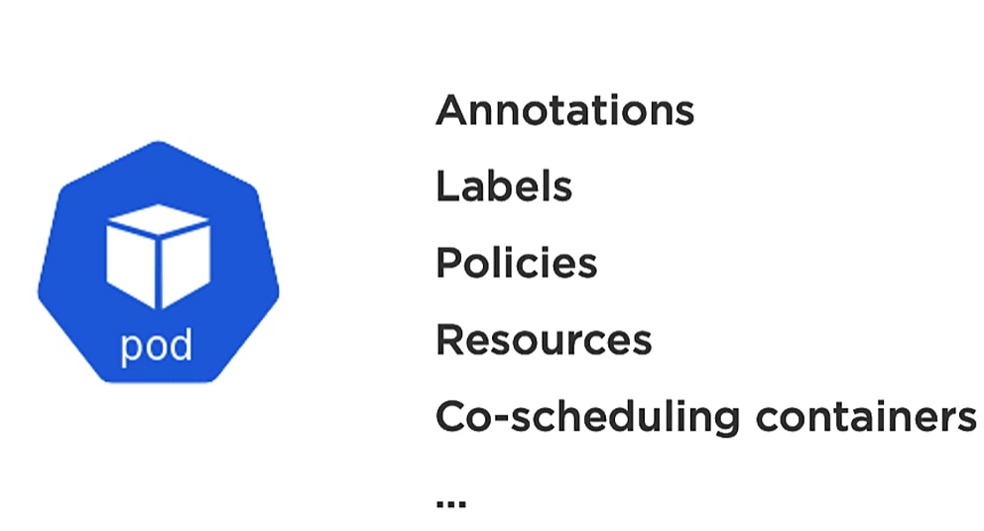

It helps in annotate and label apps with meta data which adds value.

**STABLE NETWORKING**

* Apps container are running in a POD which has an IP for container so that outside world can interact with it.
* What happens when a POD die. The deploy layer of POD fires a new POD with new IP.

**So, Problem is outside world are mapped to older IP and now new POD with new IP is assigned. So how it will work?**

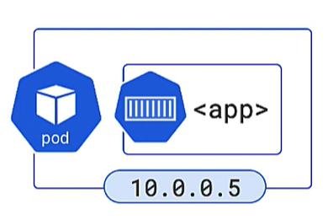

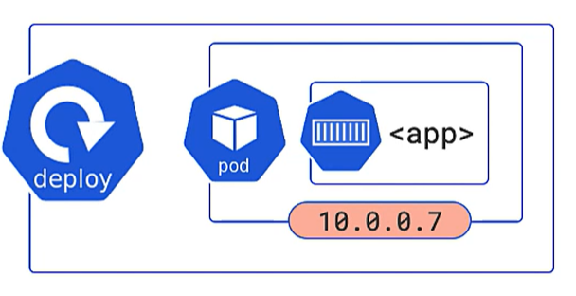

* **Not only when POD die whenever we scale a POD also new POD with new IP is created. So how client will know?**

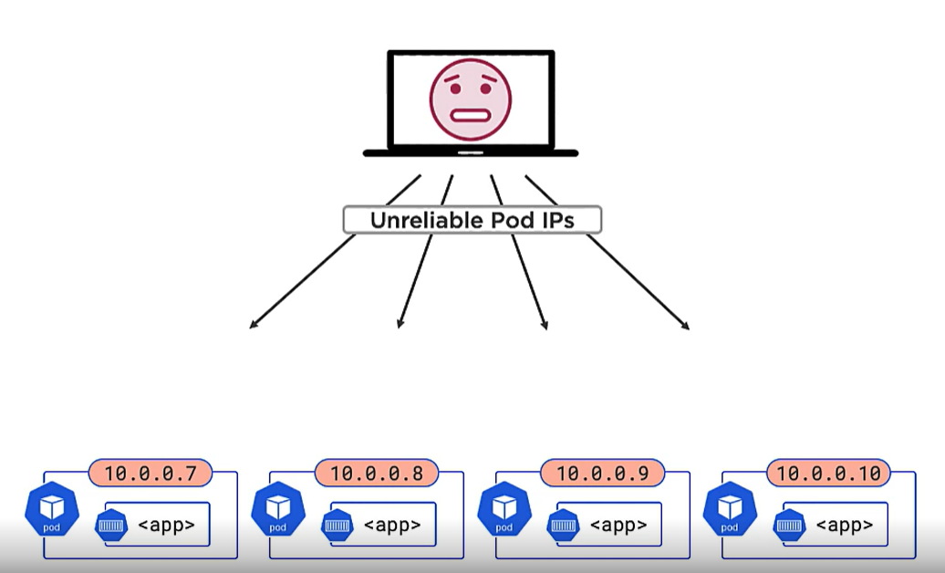

**SOLUTION:** To have an intermediate **K8s Service Object** which has stable IPs and DNS name for PODs in cluster.

**When we create a manifest file we give service object and give to appserver API.**

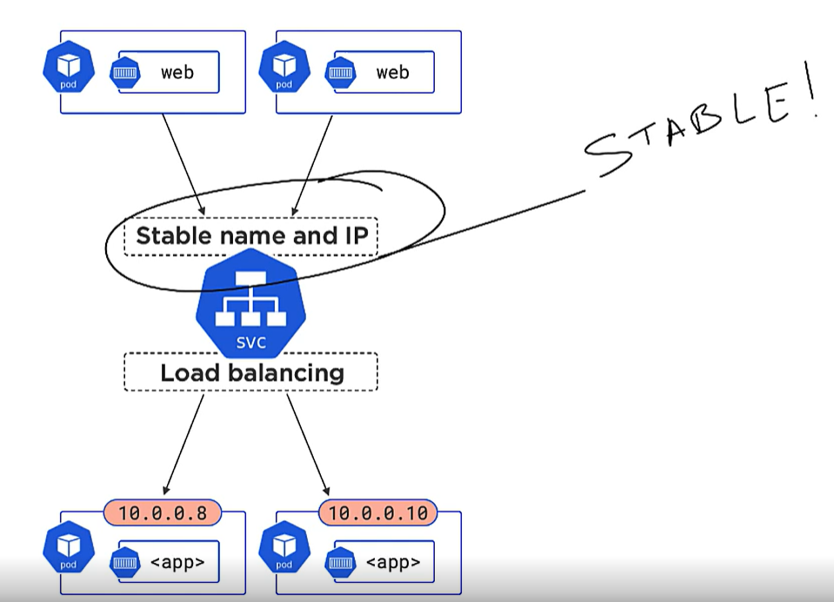

Even if the PODs down dies and new POD is created the service object just updates its list but the stable name and IP does not change for outside world.

LOAD balance happens with the help of **LABELS** in K8s.

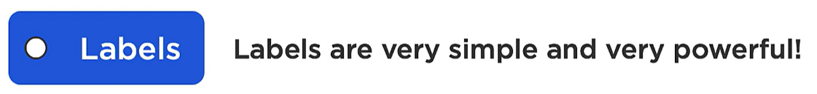

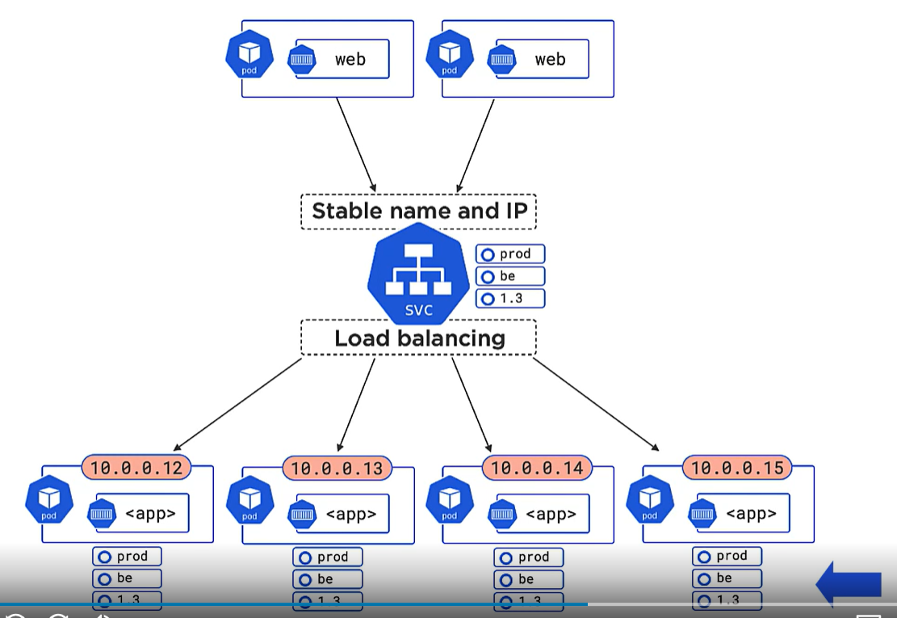

Labels tie the backend POD to the service.

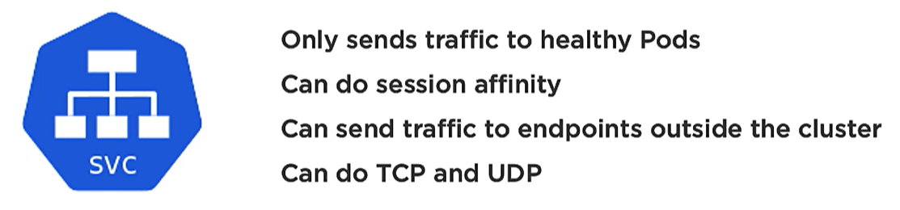

**DEPLOYMENTS LAYER**

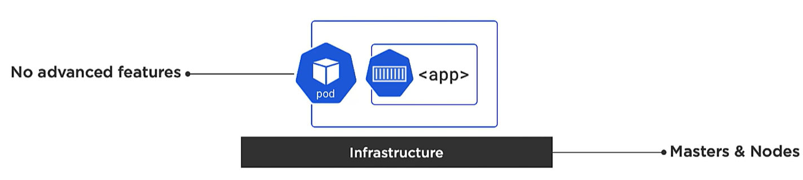

PODs by themselves doesn’t do self-healing or scaling.

We need a high-level controller which does these stuffs.

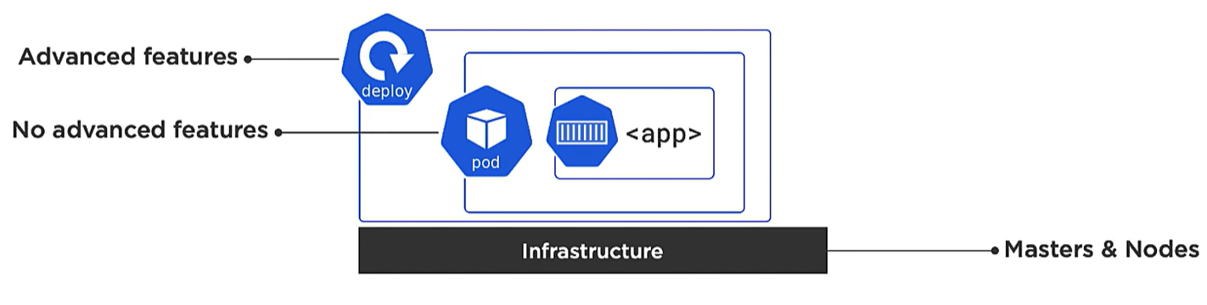

DEPLOYMENTS CONTROLLER TYPES:

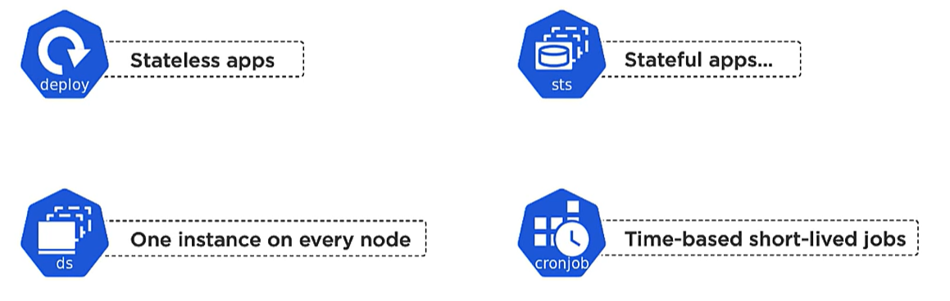

All deployment controllers are implemented by controllers of master.

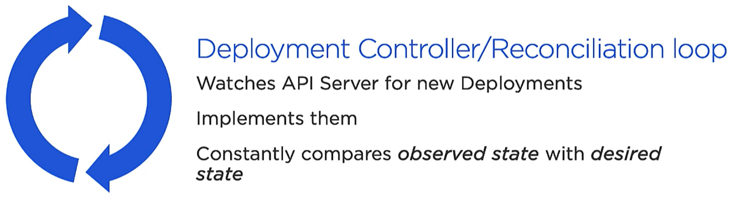

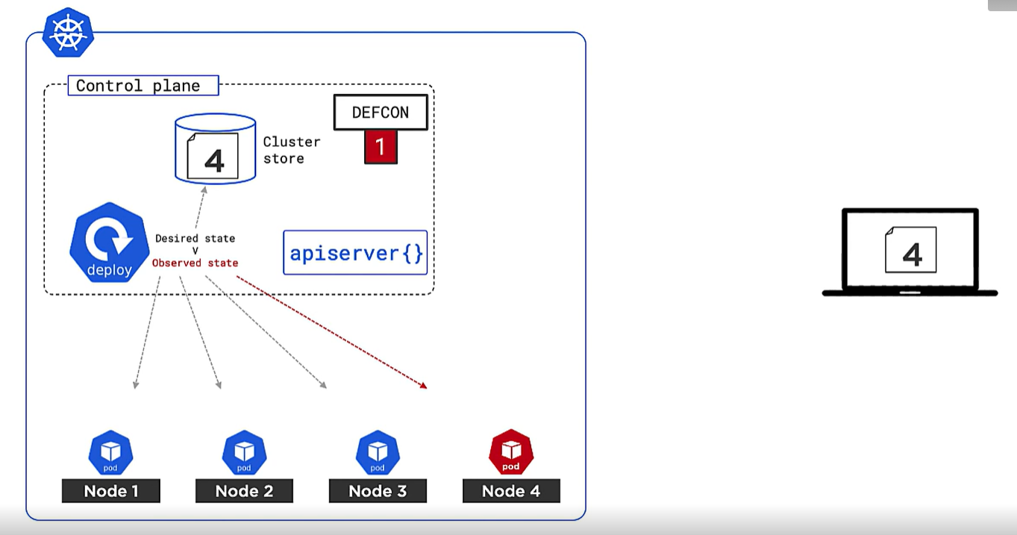

We create our yml manifest file saying we need 4 replica of our service.

We call apiserver{} , the desired state is stored in cluster store.

Then scheduler will create 4 POD on different nodes.

The deploy controller keeps on watching the desired state and observed state and do scaling or self-healing.

**ALL these are part of K8s as a user we never see that.**

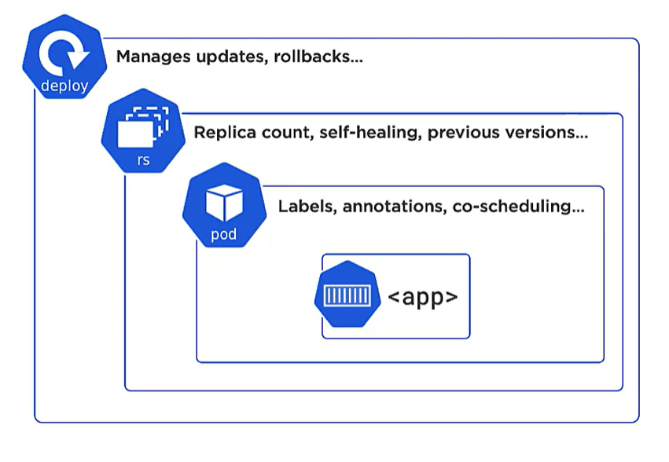

**K8s API and API server**

In K8s we have multiple independent service objects which work together to deploy cloud-native application.

Each one of these is independent object in K8s API.

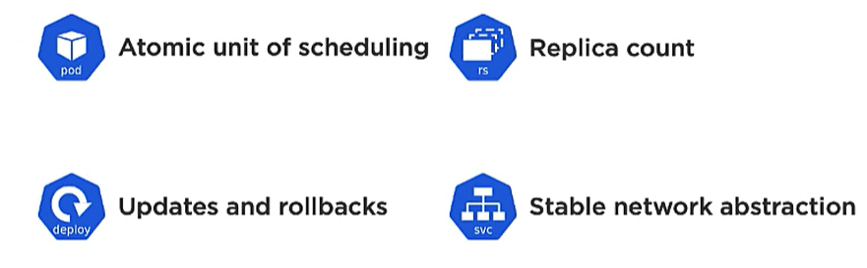

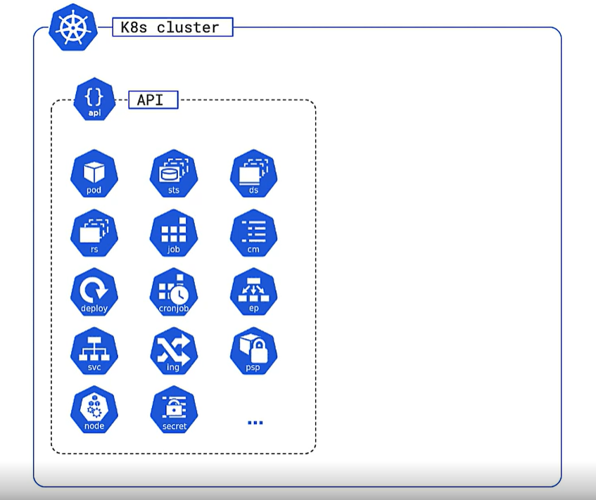

API is a catalog of what individual object does. It contains feature of each object.

**APIserver** is a control plane feature which exposes API over secured restful endpoint.

It is an intermediate server to communicate with K8s API.

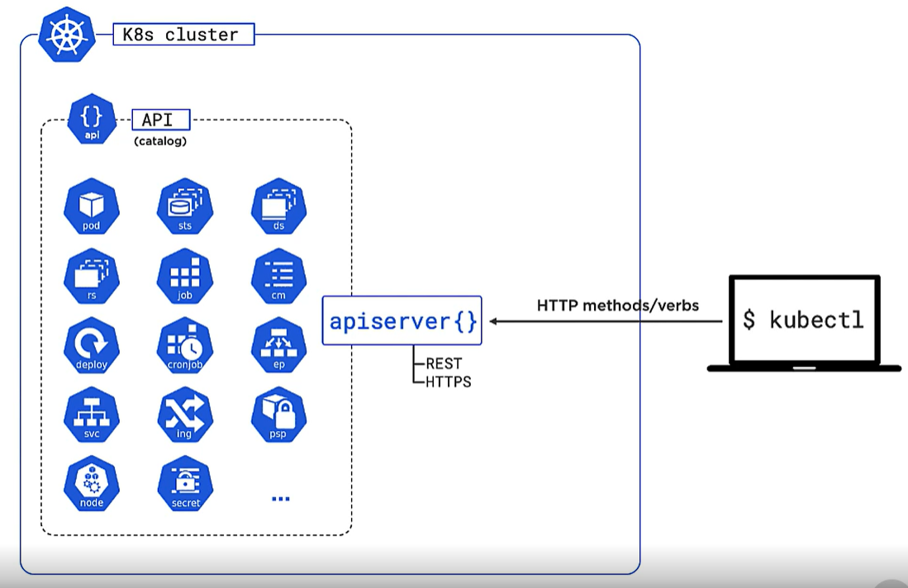

We use Kubectl command to send our manifest to apiserver as well as we can query the state of each objects using Kubectl.

It has versioned different object into subgroups.

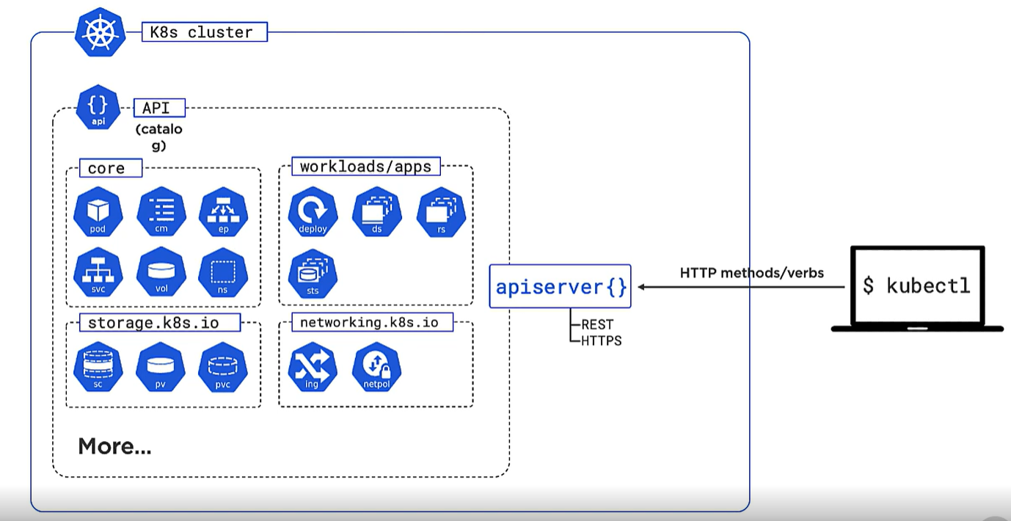

**RECAP**

**INFRASTURE STUFF**

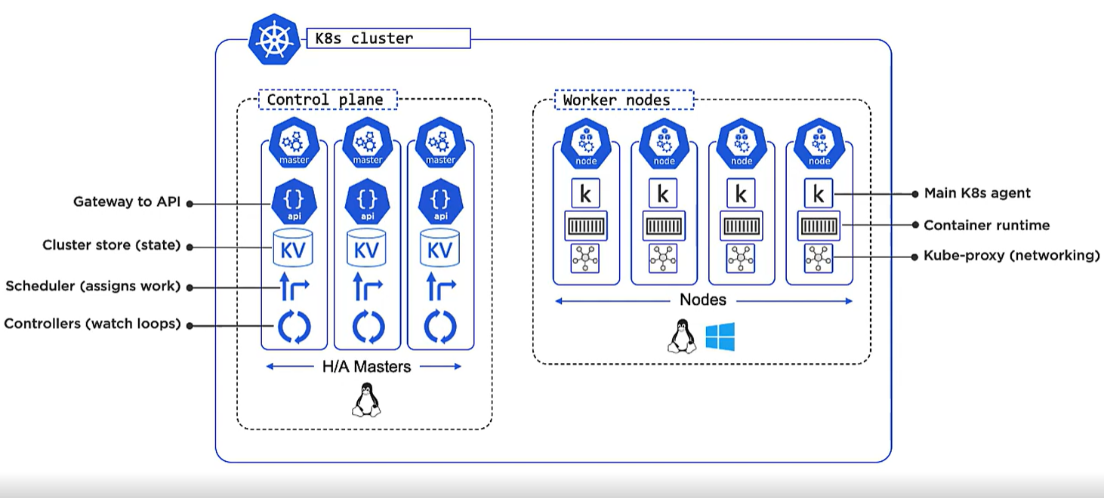

**WORKLOAD STUFF**

